1. Run hello-world docker container and observe the container status.

Command ” docker container run hello-world”

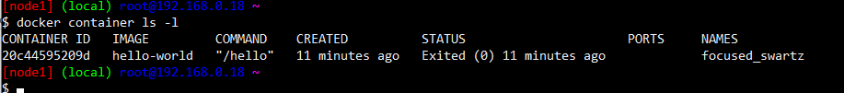

1. Check the docker images and also write down the size of hello-world image.

Command “ docker image ls “

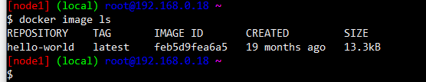

1. Run the nginx container with name as nginx1 and expose it on 8080 port on docker host.

Command “ docker container run –-name nginx1 –d –p 8080:80 nginx “



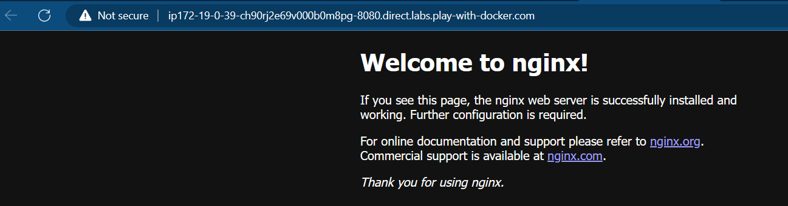

4. Explain docker container lifecycle

**Docker container lifecycle**

* Docker lifecycle states
  + Created

Command “ docker container create –name jagadeesh nginx “

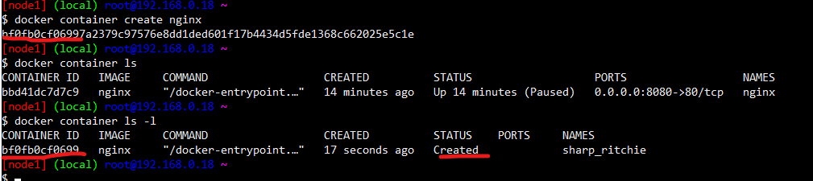

* + Running

Command “ docker container start jagadeesh “

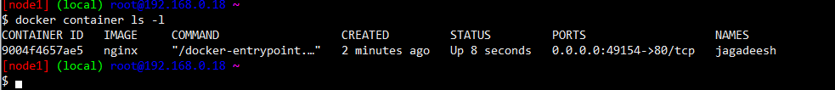

* + Paused

Command “ docker container pause jagadeesh “



* + Stopped

Command “ docker container stop jagadeesh “

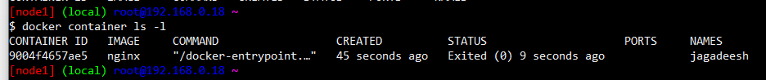

* + Deleted

Command “ docker container rm –f jagadeesh “

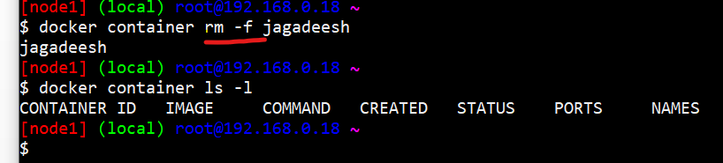

5. Explain what happens when you run the docker container.

* docker client will forward the request to docker daemon
* docker daemon will check if the image exists locally. if yes creates the container by using image
* if the image doesnot exist, then docker daemon tries to download the image from docker registry connected. The default docker registry is docker hub.
* Downloading image into local repo from registy is called as pull.
* Once the image is pulled the container is created.

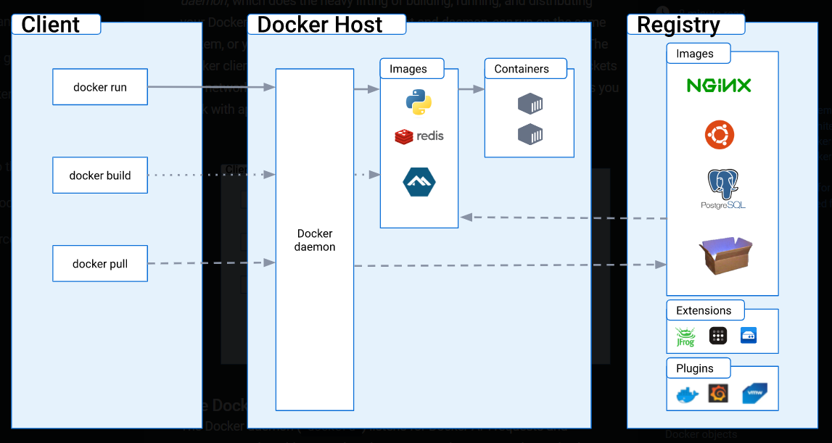

6. Explain the Docker Architecture

Docker uses a client-server architecture. The Docker client talks to the Docker daemon, which does the heavy lifting of building, running, and distributing your Docker containers. The Docker client and daemon can run on the same system, or you can connect a Docker client to a remote Docker daemon. The Docker client and daemon communicate using a REST API, over UNIX sockets or a network interface. Another Docker client is Docker Compose, that lets you work with applications consisting of a set of containers.

7. How to pull an image

Command “ docker image pull <name of image>” (latest image)

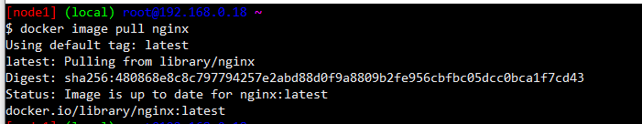

Command “ docker image pull <name:tag>” (lmage with required version)

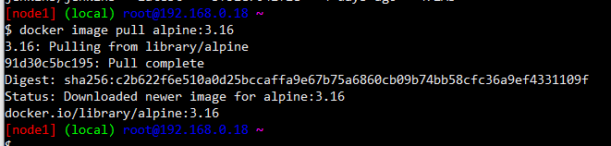

8. Delete an image

Command “docker image rm <name>”

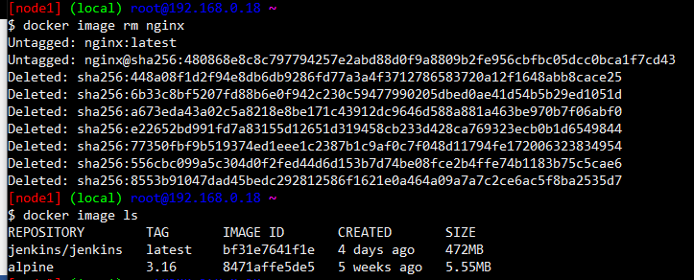

if i have to delete all the images `docker image rm $(docker image ls -q)

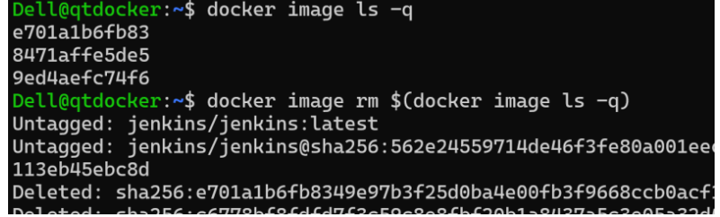

9. create and run a container

“ docker container run –d <name of image>”

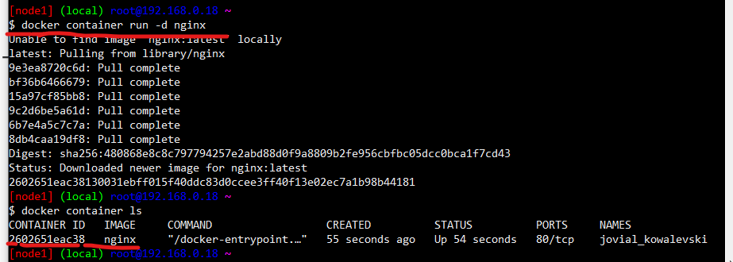

“docker container run --name jaga –d nginx:1.22”

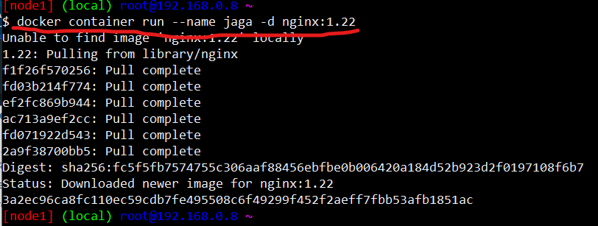

Remove all containers “docker container rm -f $(docker container ls -a -q )“

Remove specific container “ docker container rm –f <name of container>”

10. create image from container

docker container commit <container name> <image name:tag>

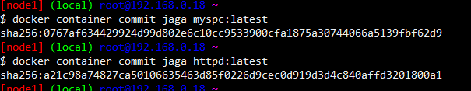

11. Build an image from the dockerfile.(base image model)

FROM amazoncorretto:11

RUN curl https://referenceapplicationskhaja.s3.us-west-2.amazonaws.com/spring-petclinic-2.4.2.jar -o spring-petclinic-2.4.2.jar

EXPOSE 8080

CMD [ "java", "-jar", "spring-petclinic-2.4.2.jar" ]

docker image build –t <image:tag> <path of file>

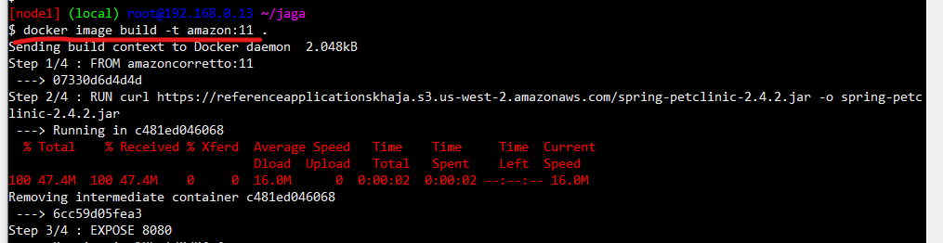

Lets run the container docker container run -d -P --name jaga myspc:1.2

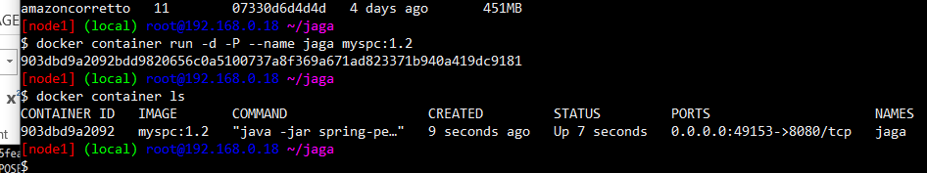

12. Build a docker image from file and inspect the image

Docker file

FROM amazoncorretto:11

LABEL author="Jagadeesh"

LABEL purpose="practice"

LABEL class="joip"

RUN curl https://referenceapplicationskhaja.s3.us-west-2.amazonaws.com/spring-petclinic-2.4.2.jar -o spring-petclinic-2.4.2.jar

EXPOSE 8080

CMD [ "java", "-jar", "spring-petclinic-2.4.2.jar" ]

Inspect the image “docker image inspect label:1”

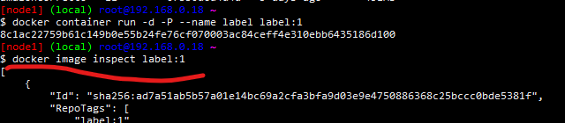

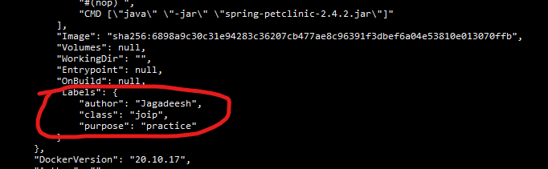

13. To install apache server and tomcat9

“sudo apt update”

“sudo apt install tomcat9”

“sudo apt install apache2”

“sudo systemctl start <server_name>” (To start the server)

“sudo systemctl stop <server_name>” (To stop the server)

“sudo systemctl restart <server_name>” ( To restart server)

“sudo systemctl status <server_name> ( to check the status of the server)

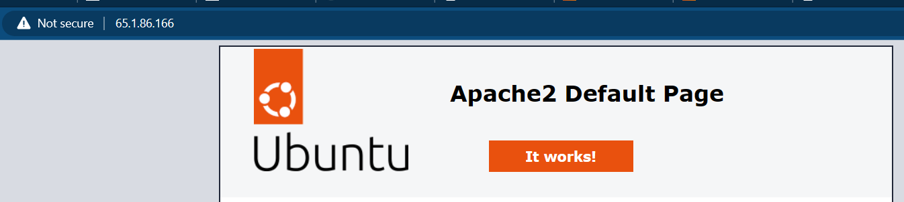

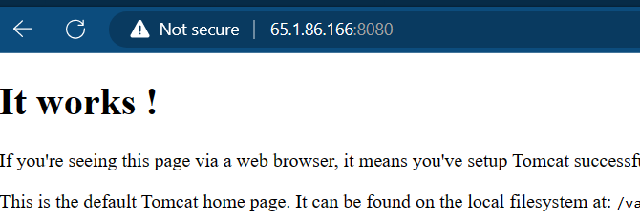

14. Running nopCommerce with file.

FROM mcr.microsoft.com/dotnet/sdk:7.0

LABEL author="khaja" organization="qt" project="learning"

ADD https://github.com/nopSolutions/nopCommerce/releases/download/release-4.60.2/nopCommerce_4.60.2_NoSource_linux_x64.zip /nop/nopCommerce_4.60.2_NoSource_linux_x64.zip

WORKDIR /nop

RUN apt update && apt install unzip -y && \

    unzip /nop/nopCommerce_4.60.2_NoSource_linux_x64.zip && \

    mkdir /nop/bin && mkdir /nop/logs

EXPOSE 5000

CMD [ "dotnet", "Nop.Web.dll","--urls", "http://0.0.0.0:5000" ]

Build image from file “docker image build -t nop:1 .”

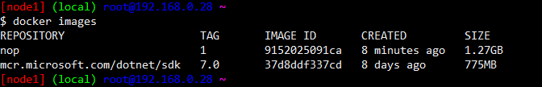

Create a container from the image “docker container run -d -p 30000:5000 --name nop nop:1 “

